Tracking Public Infrastructure and Toll Payment

A Project report submitted in partial fulfillment of 7th semester indegree of

BACHELOR OF ENGINEERING IN COMPUTER SCIENCE AND ENGINEERING

# Team ID: NM2023TMID03921

***Submitted by***

| S.Gowtham | 950320104007 |
| --- | --- |
| S.Sudhan | 950320104025 |
| J.Thesai Jebas | 950320104027 |
| C.Thomas Abraham | 950320104028 |



DEPARTMENT OF COMPUTER SCIENCE AND ENGINEERING

# GRACE COLLEGE OF ENGINEERING, THOOTHUKUDI

ANNA UNIVERSITY: CHENNAI 600025

1. **INTRODUCTION** 
   1. Project Overview
   2. Purpose
2. **LITERATURE SURVEY** 
   1. Existing problem
   2. References
   3. Problem Statement Definition
3. **IDEATION PROPOSED SOLUTION** 
   1. Empathy Map Canvas
   2. Ideation & Brainstorming
4. **REQUIREMENT ANALYSIS** 
   1. Functional requirement
   2. Non-Functional requirements
5. **PROJECT DESIGN** 
   1. Data Flow Diagram & User Stories
   2. Solution Architecture
6. **PROJECT PLANNING & SCHEDULING** 
   1. Technical Architecture
   2. Sprint Planning & Estimation
   3. Sprint Delivery Schedule
7. **CODING & SOLUTIONING (Explain the features added in the project along with code)** 
   1. Feature1
   2. Feature2
   3. Database Schema (if Applicable)
8. **PERFORMANCE TESTING** 
   1. Performance Metrics
9. **RESULTS** 
   1. Output Screenshots
10. **ADVANTAGES & DISADVANTAGES**
11. **CONCLUSION**
12. **FUTURESCOPE**
13. **APPENDIX**

Source Code

GitHub & Project Demo Link

**1.INTRODUCTION**

* 1. **Project Overview:**

**Tracking Public Infrastructure and Toll Payments**

**Using Blockchain**

The project aims to leverage blockchain technology to enhance the tracking of public infrastructure and streamline toll payments. By integrating the security, transparency, and efficiency of decentralized ledgers, this initiative seeks to address challenges in traditional toll collection systems and improve overall infrastructure management.

As the project unfolds, it will contribute to the development of a trusted digital platform for infrastructure management and payment systems, paving the way for future innovations in the field of public infrastructure and transportation.

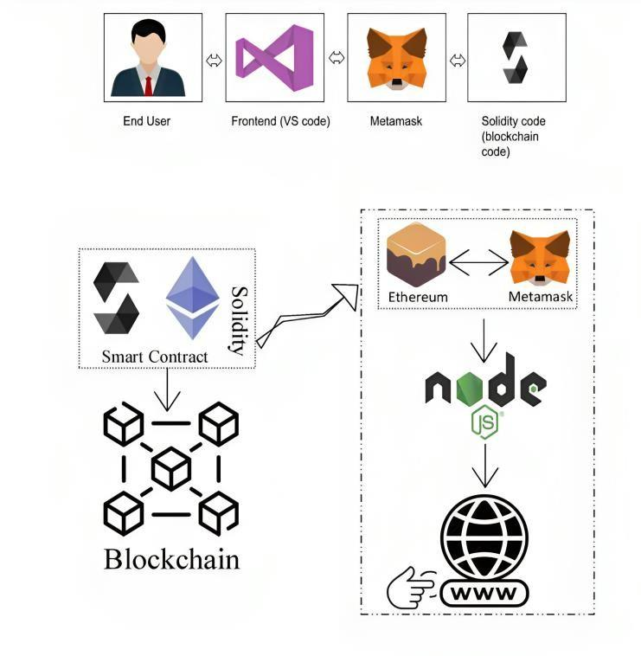

Fig:Solution Architecture Diagram

* 1. **Purpose:**

The blockchain-based Tracking Public Infrastructure and Toll Payments can offer several advantages and purposes when compared to traditional methods of tracking and toll payments. Here are some of the key purposes and benefits:

1. **Secure and transparent transactions:** Blockchain provides a secure and transparent mechanism for making, recording, and verifying toll transactions. This feature enhances the trust and reliability of the toll collection process, reducing the potential for fraud and errors.
2. **Efficient toll collection:** The use of blockchain technology can make toll collection faster and more cost-effective for both the government and users. By automating the payment process and eliminating the need for manual toll collection, the project can reduce congestion and improve the overall efficiency of transportation systems.
3. **Enhanced infrastructure management:** The integration of blockchain technology allows for better tracking and management of public infrastructure. This capability increases the transparency and traceability of toll transactions, enabling more effective maintenance and planning of infrastructure projects.
4. **Interoperability:** The smart contract can interact with other financial systems, both centralized and decentralized. This feature ensures that the project can be integrated with existing infrastructure and payment systems, promoting national interoperability and cross-border transactions.
5. **Regulatory compliance:** The project will ensure that all financial transactions and operations align with regulatory requirements and standards. This feature is essential for ensuring that the project is compliant with existing regulations and can be adopted by government agencies and financial institutions.
6. **Disaster recovery and resilience:** The use of decentralized ledger technology can enhance the project's ability to recover and operate in case of system failures or disasters, ensuring financial system resilience.
7. **Stakeholder engagement:** The project can engage stakeholders, such as financial institutions, government agencies, and the public, to ensure that the benefits of the project are widely understood and appreciated.
8. **Regulatory sandbox:** The establishment of a regulatory sandbox can allow innovative fintech companies to collaborate with the government in developing and testing blockchain solutions, promoting innovation in the financial sector.

**2.LITERATURE SURVEY**

# 2.1 Existing problem

1. **Legacy Systems and Integration Challenges:** The integration of smart contracts into legacy systems can pose technical and operational challenges. The project will need to carefully consider the choice of distributed ledger technology, scalability of the network infrastructure, security and privacy measures, and integration with current financial systems.
2. **Scalability Issues:** Blockchain technology has scalability limitations that may hinder the adoption of smart contracts by government agencies. The project will need to address these limitations to ensure that the system can handle the volume of transactions required for efficient toll collection.
3. **Security Concerns:** Blockchain technology is not immune to security vulnerabilities, including the risk of smart contract exploits and hacks. The project will need to address these concerns to ensure that the system is secure and reliable for users.
4. **Privacy and Confidentiality:** The use of blockchain technology raises concerns about the potential exposure of sensitive financial data. The project will need to address these concerns to ensure that user data is protected and confidential.
5. **Regulatory and Legal Ambiguities:** The integration of blockchain technology into public infrastructure and toll payment systems raises regulatory uncertainties and legal complexities. The project will need to address these ambiguities to ensure that the system is compliant with existing regulations and can be adopted by government agencies and financial institutions.
6. **Interoperability Challenges:** The lack of interoperability between different blockchain platforms can hinder cross-border transactions and financial system integration. The project will need to address these challenges to ensure that the system can be integrated with existing infrastructure and payment systems.
7. **Lack of Standardization:** The absence of standardized protocols and practices in the development of smart contracts for government agencies can hinder the adoption of blockchain technology. The project will need to address this lack of standardization to ensure that the system is efficient and reliable.
8. **Consensus Mechanisms and Energy Consumption:** The choice of consensus mechanisms in blockchain networks can impact the energy consumption of the system. The project will need to consider the energy consumption of the system to ensure that it is sustainable and environmentally friendly.
9. **Financial Inclusion Barriers:** The project will need to ensure that smart contracts and toll payment systems promote financial inclusion for marginalized populations. This feature is essential for ensuring that the system is accessible to all users.
10. **Cross-Border Regulatory Compliance:** The project will need to comply with international regulations and anti-money laundering (AML) laws when using smart contracts for cross-border payments.

# 2.2 Reference

Examines fintech innovations, including blockchain and smart contracts.

Discusses their transformative potential in the banking industry.

Analyzes potential risks and mitigation strategies.

"Designing a Distributed Ledger Technology System for Interbank Settlements" published in the Review of Financial Studies.

Explores the application of DLT (Distributed Ledger Technology) for interbank settlements.

Highlights the advantages of DLT over traditional systems.

Discusses challenges in scalability and interoperability.

Deep dives into the technical aspects of blockchain in finance.

Analysis of emerging trends like DeFi (Decentralized Finance).Studies on security and privacy concerns related to blockchain in banking.

"Mastering Blockchain" by Imran Bashir: A comprehensive guide covering the potential of blockchain in various industries, including banking.

"Blockchain Basics: A Non-Technical Introduction in 25 Steps" by Daniel Drescher: Great for understanding the foundational concepts.

**White Papers:**

"The Bitcoin Whitepaper" by Satoshi Nakamoto: The foundational document for decentralized digital currencies.

Ethereum White Paper: Provides insights into smart contracts and decentralized applications.

**Research Papers & Articles:**

"Smart Contracts on the Blockchain – A Bibliometric Analysis and Review" published in the "Journal of King Saud University - Computer and Information Sciences."

"Banking on Blockchain: Costs Savings Thanks to the Blockchain Technology" - a study on how blockchain can influence cost savings in the banking sector.

# 2.3 Problem Statement Definition

Traditional toll collection systems often require intermediaries, leading to delays and increased transaction costs. Current digital payment models may lack standardized regulations, governance, and verification processes. Potential risks associated with fraudulent activities, double-spending, and unauthorized creation of funds in the absence of a secure mechanism.

Need for a Solution:

To provide a decentralized yet regulated mechanism that ensures the authenticity and integrity of transactions related to public infrastructure and toll payments. To allow for programmable conditions to be associated with payment issuance, distribution, and transaction verifications, enhancing transparency and traceability.

Goals of the Smart Contract System:

Development of a secure and tamper-proof smart contract system to facilitate and manage toll payment transactions. Reduction in the dependency on intermediaries by automating and ensuring compliance checks through the smart contract. Provision of a transparent mechanism for auditing and monitoring toll payment transactions.

Stakeholders:

Government agencies overseeing public infrastructure and toll collection systems. Financial institutions as potential integrators or users of the toll payment platform. General public and businesses as end-users and beneficiaries of the toll payment facilitated by the smart contract. Developers and cybersecurity experts to ensure the secure and efficient operation of the smart contract.

Desired Outcome:

A robust, secure, and efficient smart contract system that seamlessly integrates with public infrastructure and toll payment operations. A platform that fosters trust among users, reduces transaction costs, and enhances the speed of transactions. A transparent and easily auditable mechanism for regulators and other stakeholders.

User Accessibility and Interface:

Design a user-friendly interface and user experience strategies to make the smart contract system easily accessible and understandable for the general public and businesses.

Pilot Testing and Feedback Loop:

Conduct pilot testing with targeted user groups and gather feedback to improve the smart contract system's functionality and user experience.

Scalability and Future Integration:

Addressing the system's ability to handle growth in users and transactions and potential integrations with other financial platforms.

Training and Education:

Educate stakeholders, financial institutions, and the public about the usage and benefits of the smart contract system to ensure its successful adoption.

Risk Management and Mitigation:

Identifying potential risks related to the smart contract's operation and strategies to minimize or counteract those risks.

**3. IDEATION & PROPOSED SOLUTION**

# 3.1 Empathy Map Canvas

Our primary stakeholders have expressed a mix of excitement and apprehension as we embark on the journey of implementing a public tracking infrastructure and toll payment system using blockchain technology. They acknowledge the potential benefits of this innovation, particularly in terms of enhanced transparency, security, and operational efficiency that smart contracts can bring to central banking. However, they also harbor legitimate concerns surrounding security, privacy, and regulatory uncertainties. It is our mission to address these concerns while delivering the advantages they seek.

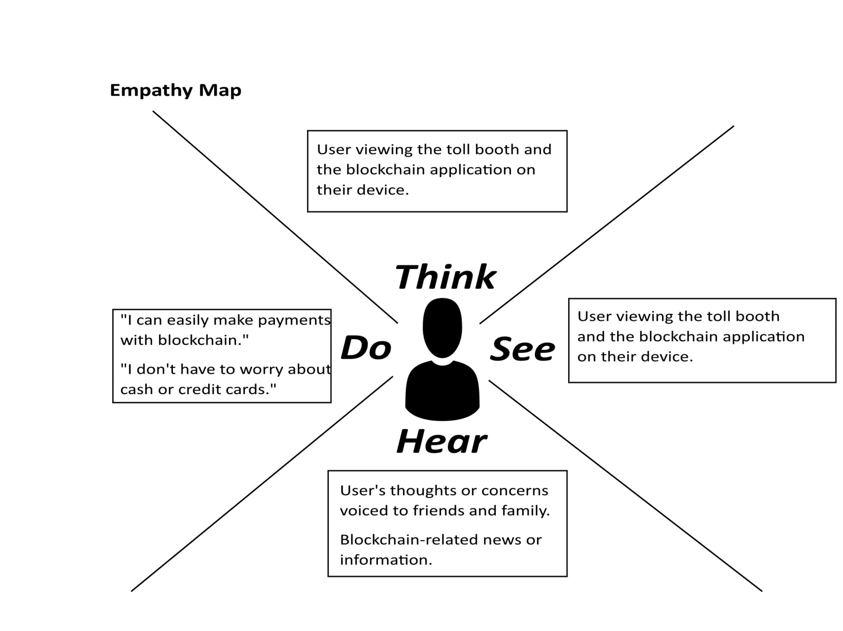

**3.2 Ideation& Brainstorming:**

**Brainstorm & Idea Prioritization Template:**

In our pursuit of implementing smart contracts within the central banking system to enhance efficiency, transparency, and security, we conducted a brainstorming and idea prioritization session to shape our innovative path forward. This session fostered an open and creative environment, encouraging participants to share their forward-thinking ideas. The outcome was a wealth of concepts that hold enormous potential for the transformation of central banking. These ideas spanned various areas, from utilizing blockchain technology to improve monetary policy implementation to tackling challenges like scalability and regulatory compliance. The next phase involves the critical task of prioritizing these ideas through a Toll tracking process. During this process, participants will allocate points to each idea based on its importance and feasibility. The ideas that accumulate the highest points will serve as guiding beacons for our project teams as they construct action plans and establish timelines for implementation. The brainstorming and prioritization process is an ongoing commitment, reflecting our dedication to a culture of continuous improvement as we endeavor to modernize our central bank's operations for the betterment of our economy and society.

**Step-1: Team Gathering, Collaboration and Select the Problem Statement**

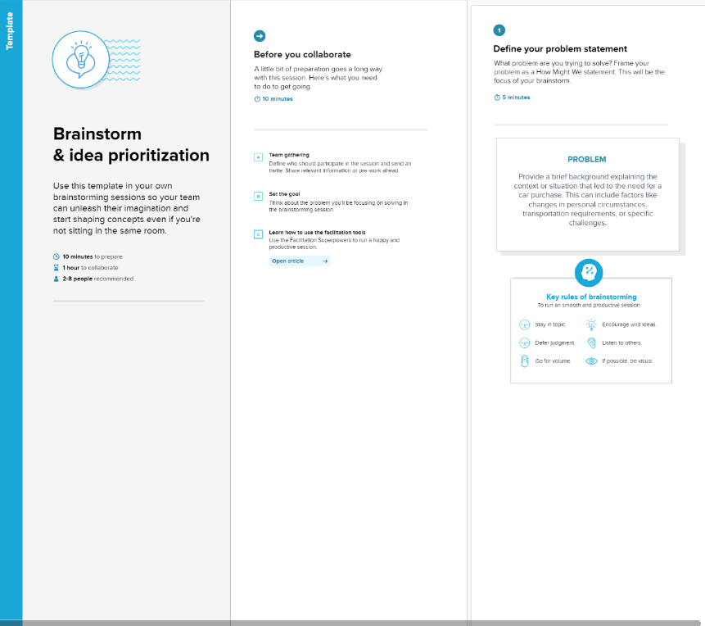

**Step-3: Idea Prioritization**

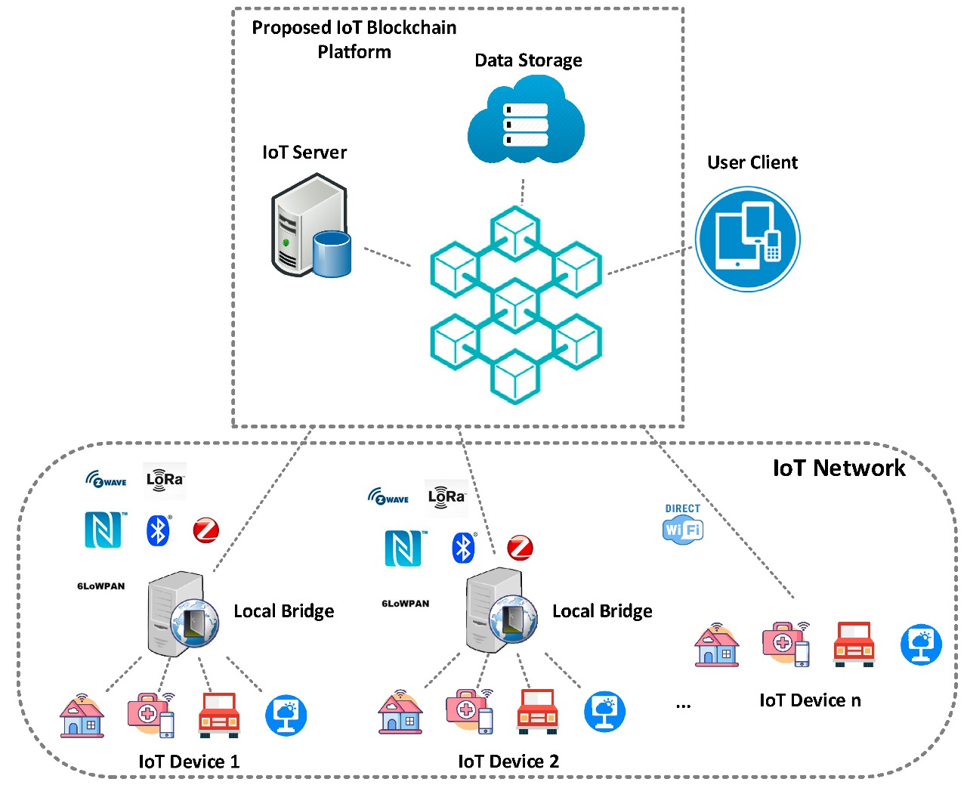

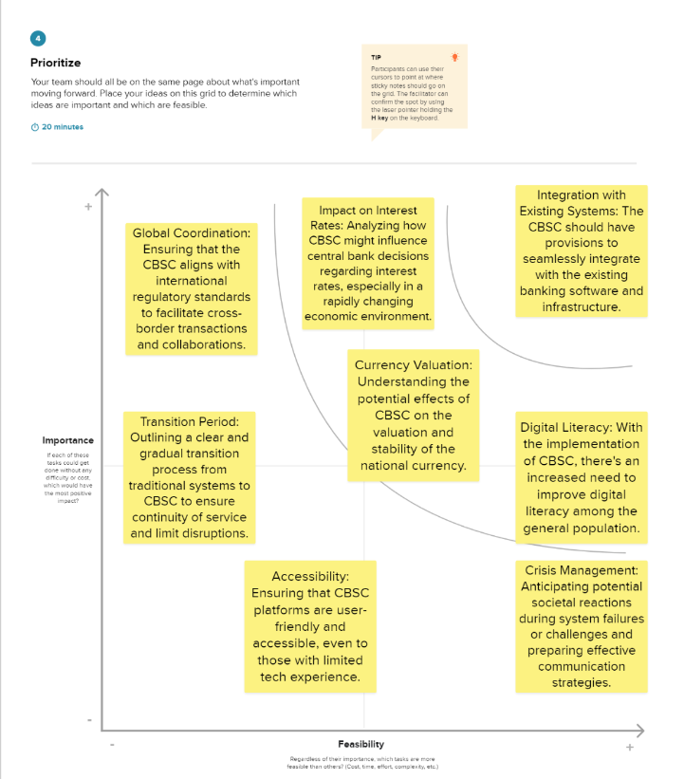

1. **. REQUIREMENT ANALYSIS**

* 1. **Functional Requirements:**

| **Requirement ID** | **Requirement Description** | **Priority** | **Notes** |
| --- | --- | --- | --- |
| FR-001 | Voter  Registration | High | Eligible voters should be able to register securely. |
| FR-002 | Ballot Creation | High | Election administrators create electronic ballots. |
| FR-003 | Secure Toll tracking | High | Voters can securely cast their votes electronically. |
| FR-004 | Voter  Verification | High | Verify voter identity before allowing them to vote. |
| FR-005 | Block chain-  Based Toll tracking | High | Record all votes as transactions on the blockchain. |
| FR-006 | Transparency and Auditing | High | Allow real-time auditing and verification of results. |
| FR-007 | Decentralization | High | Distribute the Toll tracking process across a decentralized network. |
| FR-008 | Smart Contracts | High | Automate aspects of the election process using smart contracts. |
| FR-009 | Accessibility | Medium | Ensure the system is accessible to all eligible voters. |
| FR-010 | Results  Publication | High | Provide a platform for publishing election results. |
| FR-011 | Data Protection and Privacy | High | Store voter data securely and in compliance with privacy regulations. |
| FR-012 | Voter Support | Medium | Offer support to voters encountering technical issues. |

* 1. **Non-functional Requirements:**

Following are the non-functional requirements of the proposed solution

| Requirement ID | Requirement Description | Priority | Notes |
| --- | --- | --- | --- |
| NFR-001 | Performance:  Response time | High | The system should respond to user actions within a specified time limit. |
| NFR-002 | Security: Data encryption and protection | High | All voter data and transactions must be encrypted and protected |
| NFR-003 | Scalability: Handling increased load | Medium | The system should be able to handle a growing number of voters |
| NFR-004 | Reliability:  System uptime | High | The system should be  highly reliable with minimal  downtime |
| NFR-005 | Usability: User interface | High | The user interface should be intuitive and userfriendly |
| NFR-006 | Compliance: Legal and regulatory requirements | Medium | The system should comply with all relevant election laws and regulations |

1. **. PROJECT DESIGN:**

# 5.1 Data Flow Diagram

A Data Flow Diagram (DFD) is a traditional visual representation of the information flows within a system. A neat and DFD can depict the right amount of the system requirement graphically. It shows data entering and leaving the system, what changes the information, and where data is stored.

Example: DFD Level 0 (Industry Standard)

# 5.2 Solution Architecture

**Solution Architecture:**

Solution architecture is a complex process – with many sub-processes – that bridges the gap between business problem sand technology solutions. Its goals are to:

* Find the best tech solution to solve existing business problems.
* Describe the structure, characteristics, behavior, and other aspects of the software to project stakeholders.
* Define features, development phases, and solution requirements.

**Example: Solution Architecture Diagram:**

1. **. PROJECT PLANNING AND SCHEDULING:**

**6.1 Technical Architecture:**

Technical Architecture (TA) is a form of IT architecture that is used to design computer systems. It involves the development of a technical blueprint with regard to the arrangement, interaction, and interdependence of all elements so that system-relevant requirements are met.

**6.2 Sprint Planning & Estimation**

1. **CODING & SOLUTIONING:**

**7.1 Home page:**

**home.js**

import React, { useState } from "react";

import { Button, Container, Row, Col } from 'react-bootstrap';

import 'bootstrap/dist/css/bootstrap.min.css';

import { contract } from "./connector";

function Home() {

const [Id, setId] = useState("");

const [TollAmount, setTollAmount] = useState("");

const [Manufacturer, setManufacturer] = useState("");

const [date, setDate] = useState("");

const [TranId, setTranId] = useState("");

const [Owner, setOwner] = useState("");

const [BookId, setBookId] = useState("");

const [BookDet, setBookDet] = useState("");

const [Batch, setBatch] = useState("");

const [Qty, setQty] = useState("");

const [Cus, setCus] = useState("");

const [Wallet, setWallet] = useState("");

const handleId = (e) => {

setId(e.target.value)

}

const handleTollAmount = (e) => {

setTollAmount(e.target.value)

}

const handleToll = async () => {

try {

let tx = await contract.payTollAmount(Id.toString(), TollAmount.toString())

let wait = await tx.wait()

alert(wait.transactionHash)

console.log(wait);

} catch (error) {

alert(error)

}

}

const handleDrugId = (e) => {

setTranId(e.target.value)

}

const handleNewOwner = (e) => {

setOwner(e.target.value)

}

const handleTransfer = async () => {

try {

let tx = await contract.transferDrugOwnership(TranId.toString(), Owner)

let wait = await tx.wait()

console.log(wait);import React, { useState } from "react";

import { Button, Container, Row, Col } from 'react-bootstrap';

import 'bootstrap/dist/css/bootstrap.min.css';

import { contract } from "./connector";

function Home() {

const [Id, setId] = useState("");

const [TollAmount, setTollAmount] = useState("");

const [Manufacturer, setManufacturer] = useState("");

const [date, setDate] = useState("");

const [TranId, setTranId] = useState("");

const [Owner, setOwner] = useState("");

const [BookId, setBookId] = useState("");

const [BookDet, setBookDet] = useState("");

const [Batch, setBatch] = useState("");

const [Qty, setQty] = useState("");

const [Cus, setCus] = useState("");

const [Wallet, setWallet] = useState("");

const handleId = (e) => {

setId(e.target.value)

}

const handleTollAmount = (e) => {

setTollAmount(e.target.value)

}

const handleToll = async () => {

try {

let tx = await contract.payTollAmount(Id.toString(), TollAmount.toString())

let wait = await tx.wait()

alert(wait.transactionHash)

console.log(wait);

} catch (error) {

alert(error)

}

}

const handleDrugId = (e) => {

setTranId(e.target.value)

}

const handleNewOwner = (e) => {

setOwner(e.target.value)

}

const handleTransfer = async () => {

try {

let tx = await contract.transferDrugOwnership(TranId.toString(), Owner)

let wait = await tx.wait()

console.log(wait);

alert(wait.transactionHash)

} catch (error) {

alert(error)

}

}

const handleTollDetailsId = (e) => {

setBookId(e.target.value)

}

const handleDrugDetails = async () => {

try {

let tx = await contract.getToll(BookId.toString())

let arr = []

tx.map(e => {

arr.push(e)

})

console.log(tx);

setBookDet(arr)

} catch (error) {

alert(error)

console.log(error);

}

}

const handleWallet = async () => {

if (!window.ethereum) {

return alert('please install metamask');

}

const addr = await window.ethereum.request({

method: 'eth_requestAccounts',

});

setWallet(addr[0])

}

return (

<div>

<h1 style={{ marginTop: "30px", marginBottom: "80px" }}>Toll Collection Using Blockchain</h1>

{!Wallet ?

<Button onClick={handleWallet} style={{ marginTop: "30px", marginBottom: "50px" }}>Connect Wallet </Button>

:

<p style={{ width: "250px", height: "50px", margin: "auto", marginBottom: "50px", border: '2px solid #2096f3' }}>{Wallet.slice(0, 6)}....{Wallet.slice(-6)}</p>

}

<Container>

<Row>

<Col style={{marginRight:"100px"}}>

<div>

<input style={{ marginTop: "10px", borderRadius: "5px" }} onChange={handleId} type="number" placeholder="Enter Highway Id" value={Id} /> <br />

<input style={{ marginTop: "10px", borderRadius: "5px" }} onChange={handleTollAmount} type="number" placeholder="Enter Toll amount" value={TollAmount} /> <br />

<Button onClick={handleToll} style={{ marginTop: "10px" }} variant="primary"> Pay Toll Amount</Button>

</div>

</Col>

<Col >

<div style={{ margin: "auto" }}>

<input style={{ marginTop: "10px", borderRadius: "5px" }} onChange={handleTollDetailsId} type="number" placeholder="Enter Highway Id" value={BookId} /><br />

<Button onClick={handleDrugDetails} style={{ marginTop: "10px" }} variant="primary">Get Toll</Button>

{BookDet ? BookDet?.map(e => {

return <p>{e.toString()}</p>

}) : <p></p>}

</div>

</Col>

</Row>

</Container>

</div>

)

}

export default Home;

alert(wait.transactionHash)

} catch (error) {

alert(error)

}

}

const handleTollDetailsId = (e) => {

setBookId(e.target.value)

}

const handleDrugDetails = async () => {

try {

let tx = await contract.getToll(BookId.toString())

let arr = []

tx.map(e => {

arr.push(e)

})

console.log(tx);

setBookDet(arr)

} catch (error) {

alert(error)

console.log(error);

}

}

const handleWallet = async () => {

if (!window.ethereum) {

return alert('please install metamask');

}

const addr = await window.ethereum.request({

method: 'eth_requestAccounts',

});

setWallet(addr[0])

}

return (

<div>

<h1 style={{ marginTop: "30px", marginBottom: "80px" }}>Toll Collection Using Blockchain</h1>

{!Wallet ?

<Button onClick={handleWallet} style={{ marginTop: "30px", marginBottom: "50px" }}>Connect Wallet </Button>

:

<p style={{ width: "250px", height: "50px", margin: "auto", marginBottom: "50px", border: '2px solid #2096f3' }}>{Wallet.slice(0, 6)}....{Wallet.slice(-6)}</p>

}

<Container>

<Row>

<Col style={{marginRight:"100px"}}>

<div>

<input style={{ marginTop: "10px", borderRadius: "5px" }} onChange={handleId} type="number" placeholder="Enter Highway Id" value={Id} /> <br />

<input style={{ marginTop: "10px", borderRadius: "5px" }} onChange={handleTollAmount} type="number" placeholder="Enter Toll amount" value={TollAmount} /> <br />

<Button onClick={handleToll} style={{ marginTop: "10px" }} variant="primary"> Pay Toll Amount</Button>

</div>

</Col>

<Col >

<div style={{ margin: "auto" }}>

<input style={{ marginTop: "10px", borderRadius: "5px" }} onChange={handleTollDetailsId} type="number" placeholder="Enter Highway Id" value={BookId} /><br />

<Button onClick={handleDrugDetails} style={{ marginTop: "10px" }} variant="primary">Get Toll</Button>

{BookDet ? BookDet?.map(e => {

return <p>{e.toString()}</p>

}) : <p></p>}

</div>

</Col>

</Row>

</Container>

</div>

)

}

export default Home;

# 7.2 Tolling process

**connector.js**

const { ethers } = require("ethers");

const abi = [

{

"inputs": [

{

"internalType": "uint256",

"name": "highwayId",

"type": "uint256"

}

],

"name": "getToll",

"outputs": [

{

"components": [

{

"internalType": "uint256",

"name": "timestamp",

"type": "uint256"

},

{

"internalType": "address",

"name": "collectedBy",

"type": "address"

},

{

"internalType": "uint256",

"name": "amount",

"type": "uint256"

}

],

"internalType": "struct tollCollection.TollData",

"name": "",

"type": "tuple"

}

],

"stateMutability": "view",

"type": "function"

},

{

"inputs": [

{

"internalType": "uint256",

"name": "highwayId",

"type": "uint256"

},

{

"internalType": "uint256",

"name": "_amount",

"type": "uint256"

}

],

"name": "payTollAmount",

"outputs": [],

"stateMutability": "nonpayable",

"type": "function"

},

{

"inputs": [

{

"internalType": "address",

"name": "",

"type": "address"

},

{

"internalType": "uint256",

"name": "",

"type": "uint256"

}

],

"name": "tolls",

"outputs": [

{

"internalType": "uint256",

"name": "timestamp",

"type": "uint256"

},

{

"internalType": "address",

"name": "collectedBy",

"type": "address"

},

{

"internalType": "uint256",

"name": "amount",

"type": "uint256"

}

],

"stateMutability": "view",

"type": "function"

}

]

if (!window.ethereum) {

alert('Meta Mask Not Found')

window.open("https://metamask.io/download/")

}

export const provider = new ethers.providers.Web3Provider(window.ethereum);

export const signer = provider.getSigner();

export const address = "0x7fA38198a1768Cf2105063346870d58583dE6B0F"

export const contract = new ethers.Contract(address, abi, signer)

**Source Code:**

https://drive.google.com/file/d/1wFf3E7U0So7ZedJMSmeEKzjMFRgxhriH/view?usp=sharing

**8.PERFORMANCE TESTING:**

# 8.1 Performance Metrics

**1.Transaction Processing Speed:**

Measurement of the time it takes to record and validate a vote on the blockchain. A faster processing speed ensures that the Toll tracking process is efficient and responsive, reducing voter wait times and enhancing user experience.

**2.Scalability:**

The system's ability to handle a large number of concurrent voters and transactions. Scalability is crucial to accommodate growing voter populations and to ensure that the system remains responsive under high loads during elections.

**3.Security and Data Integrity:**

The system's ability to protect against unauthorized access, tampering, or manipulation of Toll tracking data. Security metrics include the number of attempted breaches, the detection of anomalies, and the system's ability to maintain the integrity of the vote records.

**4.Voter Accessibility and Usability:**

Evaluation of how accessible and user-friendly the system is for a diverse range of voters. Metrics could include the percentage of successfully registered voters, the average time taken to cast a vote,

and feedback from voters regarding the user interface and overall experience.

**5.Fault Tolerance and Redundancy:**

Assessment of the system's ability to continue functioning in the event of hardware or network failures. Metrics can include system uptime during an election, the number of instances of system recovery, and the redundancy mechanisms in place to ensure uninterrupted service

**9. RESULTS**

# 9.1 Output Screenshots

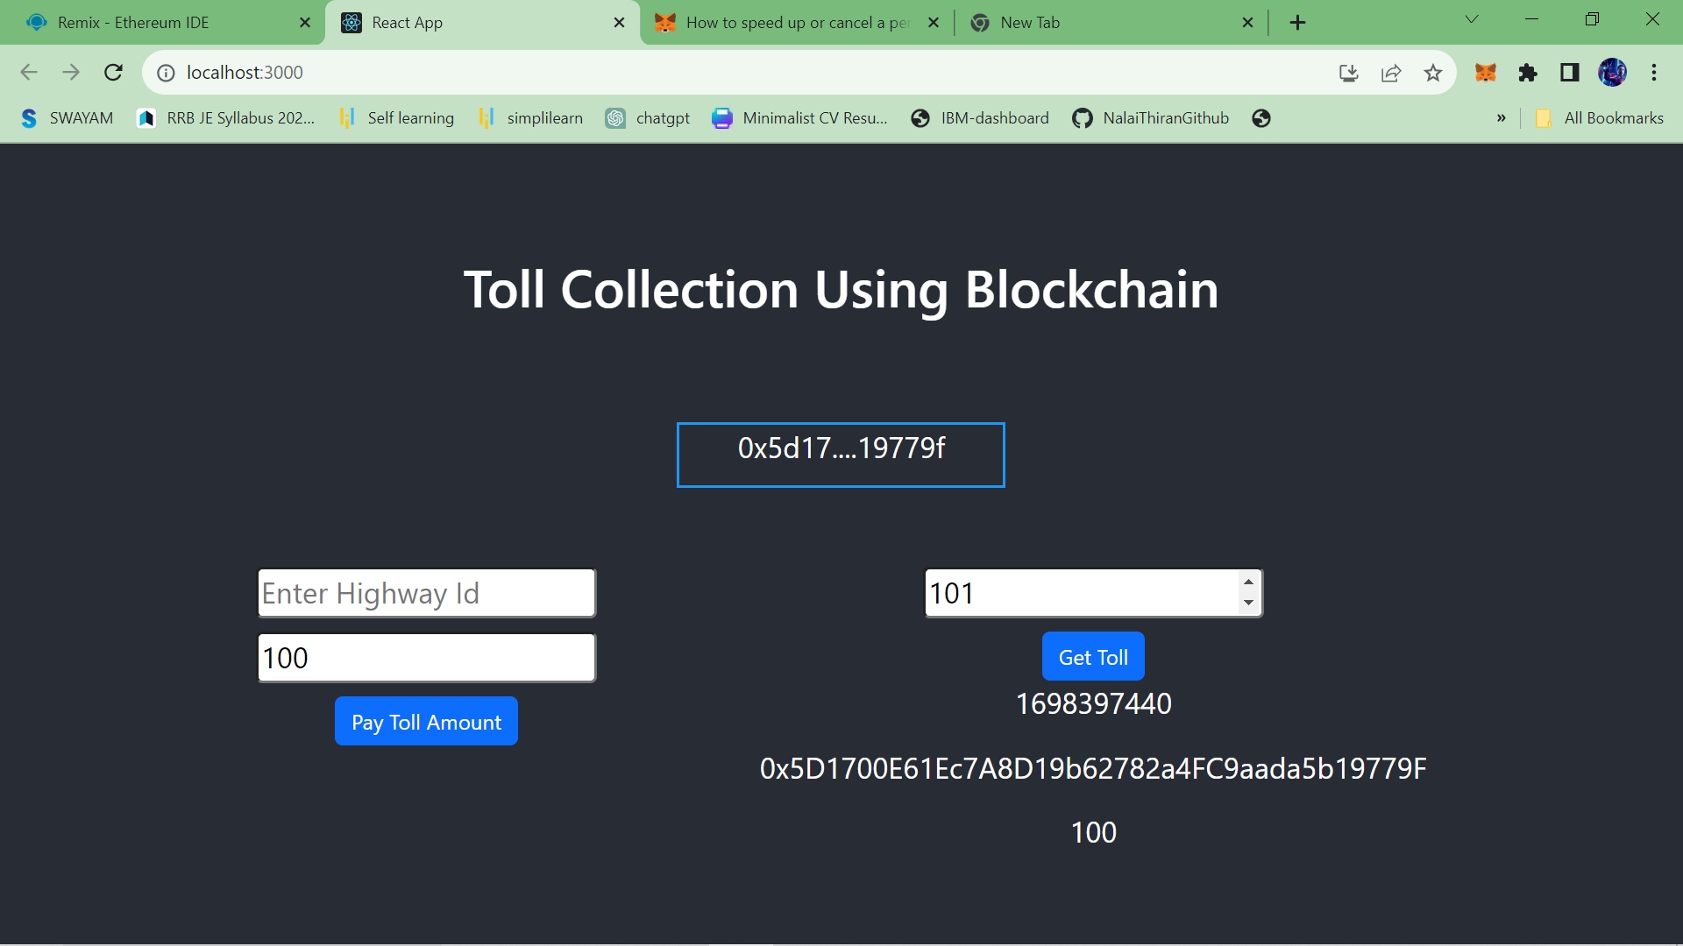

**10. ADVANTAGES & DISADVANTAGES:**

**Advantages of e-Toll tracking systems using blockchain technology:**

1. **Enhanced Transparency and Trust:**

Blockchain's decentralized and immutable ledger ensures that once a vote is recorded, it cannot be altered. This transparency and tamper resistance build trust in the electoral process.

1. **Security and Integrity:**

Blockchain's cryptographic features make it highly secure, reducing the risk of hacking, fraud, or data manipulation. Votes are cryptographically protected, enhancing data integrity.

**3.Accessibility and Convenience:**

E-Toll tracking systems can make it easier for voters to cast their ballots remotely, reducing the need for physical polling places. This can enhance accessibility for people with mobility challenges or living in remote areas.

**4.Reduced Administrative Burden:**

Streamlining the Toll tracking process through automation can reduce the administrative burden on election authorities. It can also speed up the tallying of results, potentially providing faster election outcomes.

**5.Cost Savings:**

Over the long term, e-Toll tracking systems can potentially reduce the cost of printing ballots, setting up polling stations, and manual vote counting. This can lead to cost savings for electoral bodies.

**Disadvantages of e-Toll tracking systems using blockchain technology:**

**1.Cybersecurity Risks:**

While blockchain is generally secure, e-Toll tracking systems are not immune to cybersecurity threats. Hacks, DDoS attacks, and vulnerabilities in the software can compromise the system's integrity.

**2.Digital Divide:**

Not all citizens have equal access to the internet or the technological skills to use e-Toll tracking systems. This can create disparities in Toll tracking access, potentially disenfranchising certain populations.

**3.Complexity and Usability Issues:**

E-Toll tracking systems, particularly blockchain-based ones, can be complex for voters to understand and use. Usability issues may deter participation, particularly among older or less tech-savvy voters.

**4.Identity Verification Challenges:**

Verifying the identity of online voters without compromising

Privacy can be a significant challenge. Ensuring that voters are who they claim to be remains a complex issue.

**5.Legal and Regulatory Hurdles:**

Many countries have strict regulations and laws surrounding Toll tracking procedures. Adapting these regulations to accommodate blockchain-based Toll tracking can be a complex and time-consuming process.

**11.CONCLUSION:**

In conclusion, the adoption of a blockchain-based electronic Toll tracking system offers a promising path towards redefining the democratic processes of the 21st century. This innovative technology brings with it a host of advantages, notably the assurance of security and transparency. The immutable nature of blockchain ensures that each vote cast is recorded in an indelible ledger, safeguarding the sanctity of the electoral process. Voters can verify their choices, and the decentralized structure reduces the risk of tampering or manipulation.

Furthermore, blockchain Toll tracking systems enhance accessibility and inclusivity, enabling citizens, regardless of their location or physical abilities, to participate in the electoral process. Cross-border Toll tracking becomes a reality, and the need for physical polling stations diminishes, resulting in substantial cost savings. This technological advancement opens doors to customization, innovation, and greater voter engagement.

While blockchain-based electronic Toll tracking systems hold immense potential, challenges related to privacy, identity verification, and regulatory adjustments must be diligently addressed to ensure their widespread adoption. Nonetheless, as governments, tech companies, and blockchain developers collaborate and adapt to evolving needs, this technology promises to reshape the very foundations of democracy, ensuring that the voices of citizens are not only heard but also securely and transparently counted. The future of elections is bright, driven by the assurance of trust and the empowerment of every voter.

**12. FUTURE SCOPE:**

The future scope of blockchain-based electronic Toll tracking systems is promising and holds the potential to address various challenges in the current Toll tracking processes. Here are some key aspects of its future scope:

**Enhanced Security and Transparency:**

Blockchain offers immutable and tamper-resistant records, making it highly secure.

Transparency in the Toll tracking process allows voters to verify their votes and ensures election integrity.

**Remote and Secure Toll tracking:**

Facilitates remote Toll tracking, which can improve accessibility for voters, especially those living abroad. Advanced encryption and authentication mechanisms enhance security.

**Reduced Fraud and Manipulation:**

Eliminates the risk of double Toll tracking and other forms of fraud.

Prevents manipulation of results due to the decentralized and transparent nature of blockchain.

**Streamlined Verification:**

Simplifies the verification process, reducing the need for manual checks. Accelerates the counting and verification of votes.

**Cost Reduction:**

Reduces the cost of printing physical ballots and conducting manual vote counting. Minimizes the need for physical polling stations.

**13. APPENDIX:**

**Source Code:**

[11_Problem_Statement_11_toll_collection.zip - Google Drive](https://drive.google.com/file/d/1ZE8BNn8SkAnh3qFkGB1FCvnESX8I_WtK/view)

**GitHub:**

**https://github.com/tom8245/NM2023TMID03921**

**Demo Video Link:**

**https://drive.google.com/file/d/1HRNFp_hKOBmBVWxixG8BwCcTp17EmYk/view?usp=sharing**